Dear Third Grade Explorer,
Welcome to our Terrific Third Grade Year! Our Terrific Third Grade Year will begin on Wednesday, August 26th. At that time, we will log onto our computers to meet the other Explorers in our class!
I thought you might be wondering about what to do on the first day of school:
- Have your computer ready! Charge it up or plug it in.
- Have a Summer Souvenir near your computer.
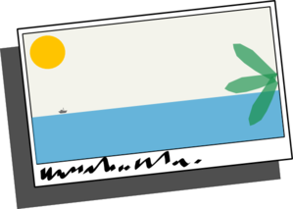
- Please find ONE souvenir from your summer. A souvenir could be a picture, drawing, postcard, seashell, camp craft, or ______________________.
- You will share your summer souvenir on one day during the first two weeks.
I hope this provides you with the information you need to get ready for the first day of our Terrific Third Grade Year! If you have other questions about our first day your parents can send me an email at: plaxtona@masonk12.net
I’m looking forward to a Terrific Third Grade Year with YOU!
Sincerely,
Mrs. Plaxton

